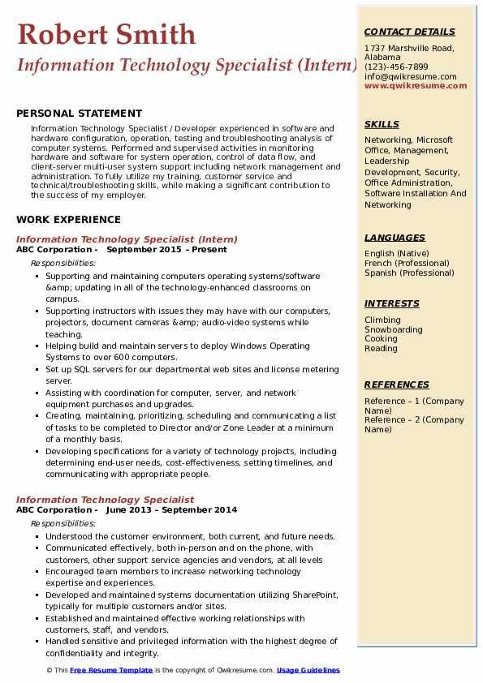
Robert Smith
CONTACT DETAILS
1737 Marshville Road,
Alabama
Information Technology Specialist (Intern) (123-456-7899
info@qwikresume.com www.qwikresume.com
PERSONAL STATEMENT
Information Technology Specialist/Developer experienced in software and hardware configuration, operation, testing and troubleshooting analysis of computer systems. Performed and supervised activities in monitoring hardware and software for system operation, control of data flow, and client-server multi-user system support including network management and administration. To fully utilize my training, customer service and technical/troubleshooting skills, while making a significant contribution to the success of my employer.
WORK EXPERIENCE
Information Technology Specialist (Intern) ABC Corporation - September 2015 - Present Responsibilities:
Supporting and maintaining computers operating systems/software &amp; updating in all of the technology-enhanced classrooms on campus.
• Supporting instructors with issues they may have with our computers, projectors, document cameras &amp; audio-video systems while teaching.
Helping build and maintain servers to deploy Windows Operating Systems to over 600 computers.
• Set up SQL servers for our departmental web sites and license metering
server.
• Assisting with coordination for computer, server, and network equipment purchases and upgrades.
Creating, maintaining, prioritizing, scheduling and communicating a list of tasks to be completed to Director and/or Zone Leader at a minimum of a monthly basis.
• Developing specifications for a variety of technology projects, including determining end-user needs, cost-effectiveness, setting timelines, and communicating with appropriate people.
Information Technology Specialist
ABC Corporation June 2013 September 2014
Responsibilities:
• Understood the customer environment, both current, and future needs. • Communicated effectively, both in-person and on the phone, with customers, other support service agencies and vendors, at all levels
⚫ Encouraged team members to increase networking technology expertise and experiences.
• Developed and maintained systems documentation utilizing SharePoint, typically for multiple customers and/or sites.
• Established and maintained effective working relationships with customers, staff, and vendors.
• Handled sensitive and privileged information with the highest degree of confidentiality and integrity.
© This Free Resume Template is the copyright of Qwikresume.com. Usage Guidelines
SKILLS
Networking, Microsoft Office, Management, Leadership
Development, Security, Office Administration, Software Installation And Networking
LANGUAGES
English (Native)
French (Professional) Spanish (Professional)
INTERESTS
Climbing Snowboarding Cooking Reading
REFERENCES
Reference 1 (Company Name) Reference - 2 (Company Name)

